

School of Future Tech
Case Study Report
on
MotoRent: Scooter & Bike Rental (HTML/CSS/JS)
by
Anurag Kharke
Jeff Bezos
150096725100

B.Tech CSE 2025–29 | HTML-5, CSS, JavaScript — Semester II | Case Study 36

Index
1. Introduction to the Case Study.
2. Problem Statement / Case Background (Abstract).
3. Problem Statement / Case Study Design.
4. Methods & Algorithms Technology Applied.
5. Implementation Details and Snapshots.
6. Results and Conclusion.
7. References

1. Introduction to the Case Study
Tourism is one of the fastest-growing industries worldwide, and two-wheeler rentals have become an essential service at popular vacation destinations. Tourists often prefer the flexibility and affordability of renting scooters and motorcycles over cabs or public transport. However, most rental services still operate through phone calls or walk-in bookings with no digital presence.
This case study focuses on designing and implementing MotoRent — a scooter and bike rental website for tourists using HTML5, CSS3, and JavaScript. The website provides a vehicle catalog page with specifications, pricing, and a CSS comparison table, along with a license verification page with JavaScript-based form validation.
The project demonstrates how core web technologies — semantic HTML for structure, CSS for responsive layouts and comparison tables, and JavaScript for client-side validation and dynamic UI — can solve a real-world problem in the transport and tourism industry.

2. Problem Statement / Case Background (Abstract)
Background
Vacation rental operators in tourist destinations like Goa, Manali, and Jaipur face challenges without a digital presence. Tourists cannot compare vehicles, check pricing, or verify license eligibility before arriving. A web-based solution is needed for vehicle browsing, comparison, and license verification.
Abstract
This case study presents MotoRent, a two-page web application. The first page (vehicles.html) serves as a vehicle catalog with 8 vehicles, dynamic filtering, a CSS comparison table, included amenities, and three-tier pricing. The second page (verification.html) implements license verification with regex validation for Indian DL format, age verification (18+), vehicle class eligibility checks, and real-time visual feedback on form fields.

3. Problem Statement / Case Study Design
1. Vehicle Catalog (vehicles.html)
- Hero section with tagline and key statistics (50+ vehicles, 12 locations).
- Filter buttons (All/Scooters/Motorcycles/Premium) with JS dynamic rendering.
- Responsive vehicle card grid with specs, pricing, and Rent buttons.
- CSS-styled comparison table with hover effects and highlighted pricing.
- Three-tier pricing plans: Daily ₹349, Weekly ₹299 (15% off), Monthly ₹249 (25% off).
2. License Verification (verification.html)
- Personal info: name, DOB (18+ check), phone (10-digit), email validation.
- License details: Indian DL format (SS-RRYYYYNNNNNNN), vehicle class (MCWG/MC only), expiry check.
- Real-time validation with green/red borders; success card with booking ID or failure with errors.

4. Methods & Algorithms Technology Applied
- Dynamic DOM Manipulation: Vehicle cards rendered from JS array using template literals and innerHTML.
- Regex Validation: DL format /^[A-Z]{2}-\d{13}$/, phone /^[6-9]\d{9}$/, email pattern matching.
- Age Calculation: Millisecond-based arithmetic from DOB, rejecting users under 18.
- Date Comparison: License expiry validated against current date using JS Date objects.
- Real-Time Feedback: Event listeners toggle CSS classes (valid/invalid) on input fields.
- CSS Grid + Flexbox: Responsive card grid with auto-fill/minmax(); Flexbox for alignment.

Technology Stack:
- HTML5 (semantic structure, forms, tables), CSS3 (variables, Grid, hover animations, comparison table), JavaScript ES6 (DOM, regex, event listeners). Google Fonts: Outfit + Space Mono. No frameworks required.

5. Implementation Details and Snapshots
The implementation consists of two self-contained HTML files with embedded CSS and JavaScript: vehicles.html (catalog, filtering, comparison table, pricing) and verification.html (form validation, license verification, result display).

Output Snapshots:
Figure 1: Hero Section & Navigation
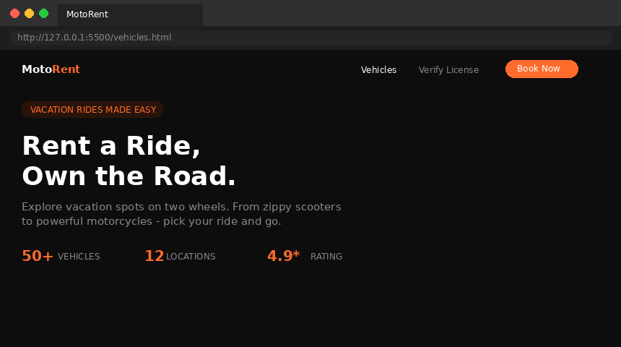
Figure 2: Vehicle Cards with Filter Bar
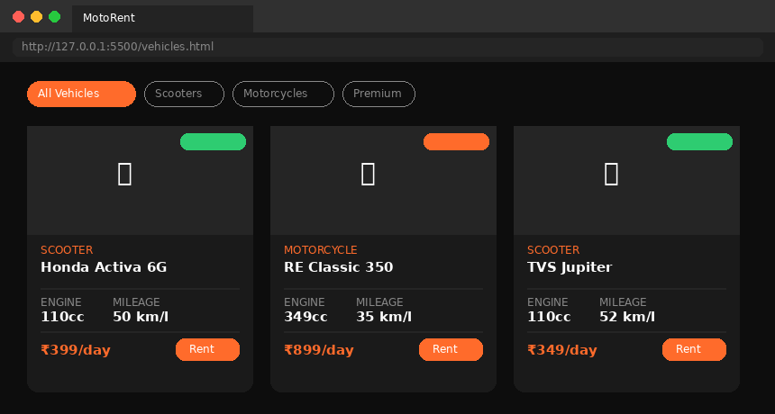
Figure 3: CSS Comparison Table
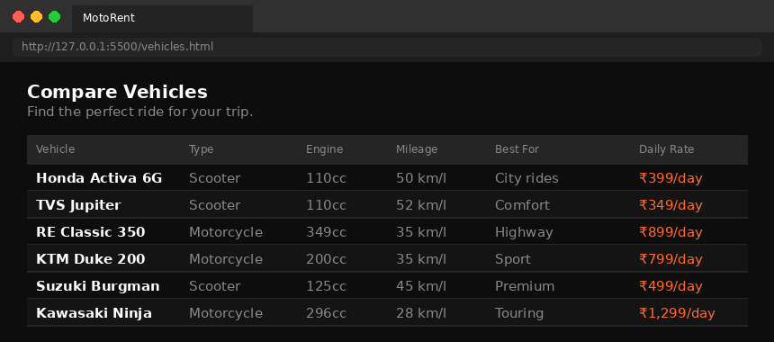
Figure 4: Pricing Plans (Daily / Weekly / Monthly)
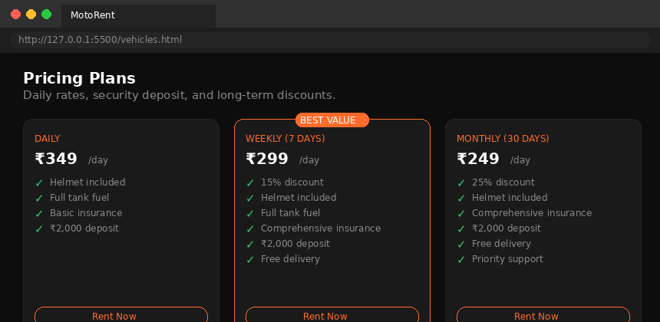
Figure 5: License Verification Form
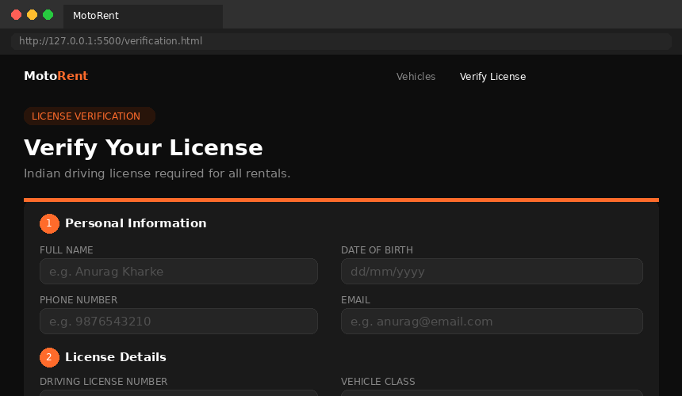
Figure 6: Real-Time Validation (Green/Red Borders)
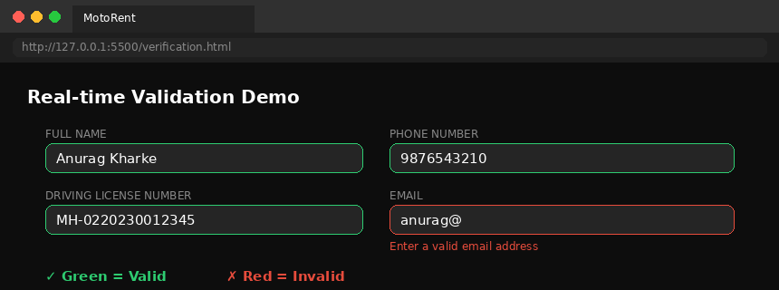
Figure 7: Successful Verification with Booking ID
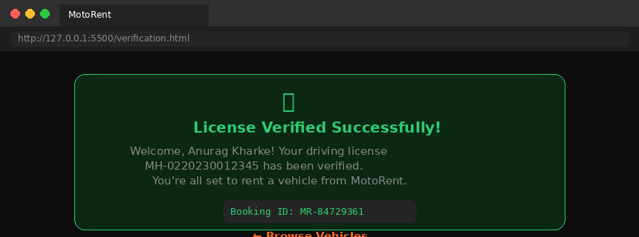
Figure 8: Failed Verification with Error Message
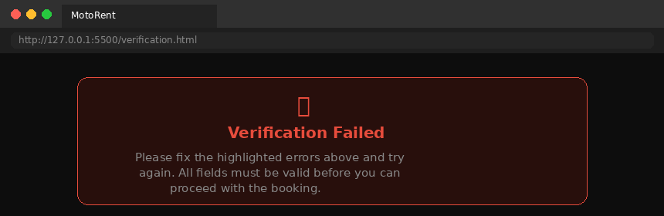

6. Results and Conclusion
Findings
- Dynamic JS rendering makes the catalog maintainable — adding a vehicle requires one array entry.
- CSS Grid provides fully responsive layouts without complex media queries.
- The comparison table gives users a clear way to compare vehicles by specs and price.
- Regex validation catches formatting errors instantly, reducing invalid submissions.
- Real-time green/red feedback improves UX over submit-only error display.
Conclusion
This case study demonstrates a complete scooter and bike rental website using HTML5, CSS3, and JavaScript. The vehicle catalog provides dynamic filtering, a CSS comparison table, and tiered pricing. The verification page implements robust client-side validation. Future enhancements could include backend integration, payment gateway, and GPS-based availability.

7. References
- MDN Web Docs — developer.mozilla.org — HTML5, CSS Grid, JS DOM API, regex.
- W3C HTML5 Specification — semantic markup and form standards.
- CSS-Tricks — css-tricks.com — responsive design and table styling.
- Google Fonts — fonts.google.com — Outfit and Space Mono families.
- Ministry of Road Transport, India — DL format and vehicle class codes.

— End of Case Study Report —

